React Lab Report - TicketBookingApp

# Introduction

This lab demonstrates conditional rendering in React by toggling views between guest and logged-in user.

# Objectives and What I Learned

- Use useState to store login state

- Render components conditionally using if, ternary, and &&

- Toggle Login/Logout button behavior

- Separate logic using component files

# Hands-on Practice Summary

Developed 'ticketbookingapp' with Login/Logout toggle. UserPage allows booking; GuestPage shows flight details. Components are conditionally rendered.

# Code Snippets

**App.js**

import React, { useState } from 'react';  
import GuestPage from './components/GuestPage';  
import UserPage from './components/UserPage';  
function App() {  
 const [isLoggedIn, setIsLoggedIn] = useState(false);  
 return (  
 <div>  
 <button onClick={() => setIsLoggedIn(!isLoggedIn)}>  
 {isLoggedIn ? 'Logout' : 'Login'}  
 </button>  
 {isLoggedIn ? <UserPage /> : <GuestPage />}  
 </div>  
 );  
}  
export default App;

**GuestPage.js**

import React from 'react';  
const GuestPage = () => {  
 const flights = [...];  
 return (  
 <div>  
 <h2>Please sign up</h2>  
 <ul>{flights.map(f => <li key={f.id}>{f.name}</li>)}</ul>  
 </div>  
 );  
};  
export default GuestPage;

**UserPage.js**

import React from 'react';  
const UserPage = () => {  
 return (  
 <div>  
 <h2>Welcome back</h2>  
 <button>Book Now</button>  
 </div>  
 );  
};  
export default UserPage;

# Screenshot

# Screenshot 2025-08-03 135420

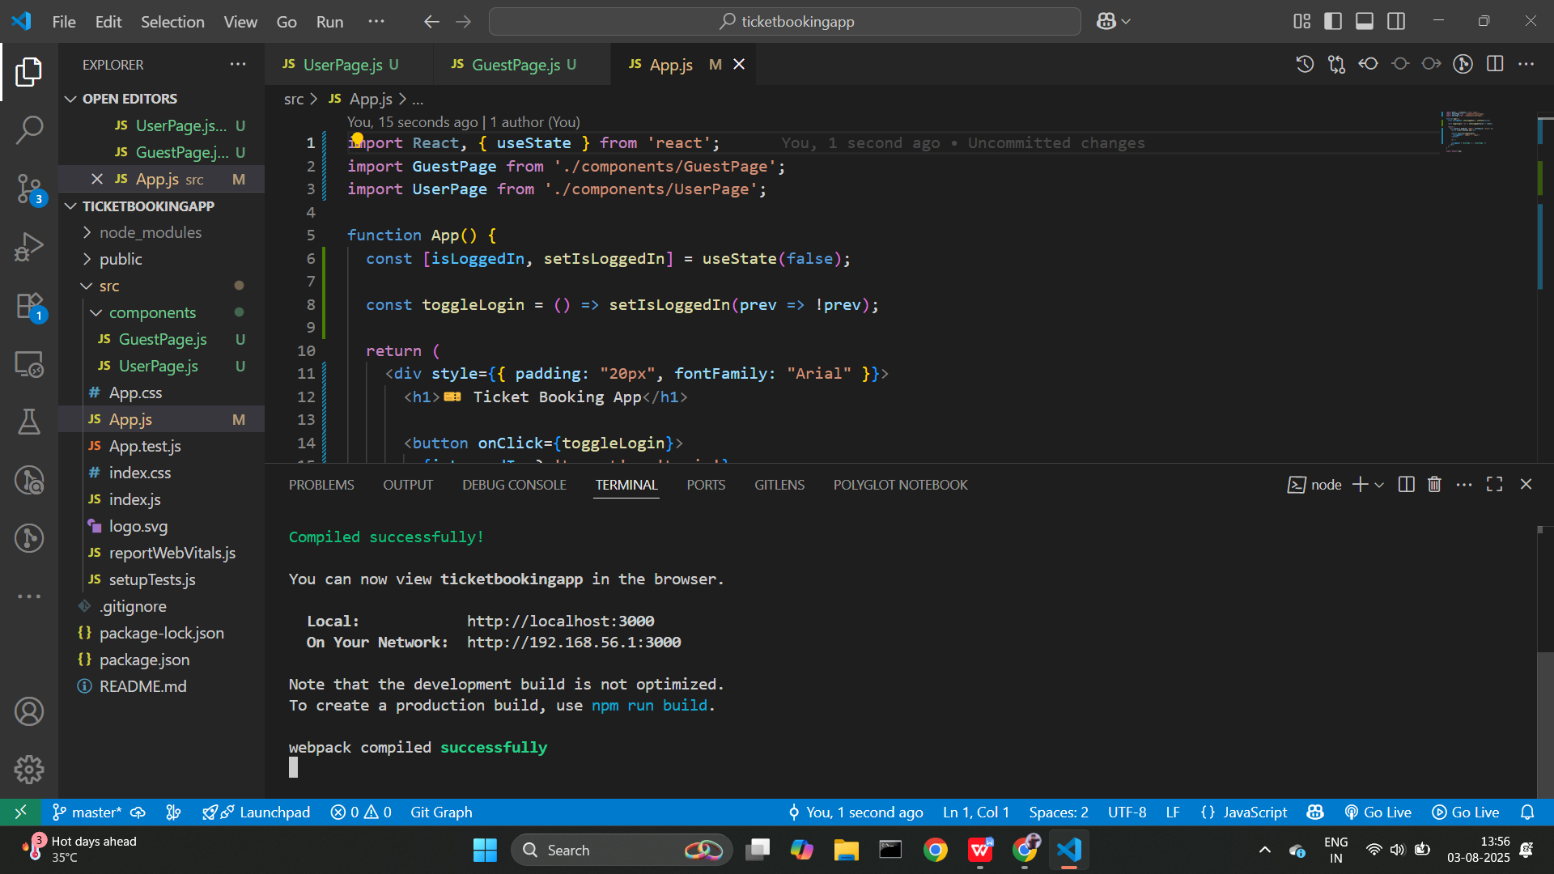

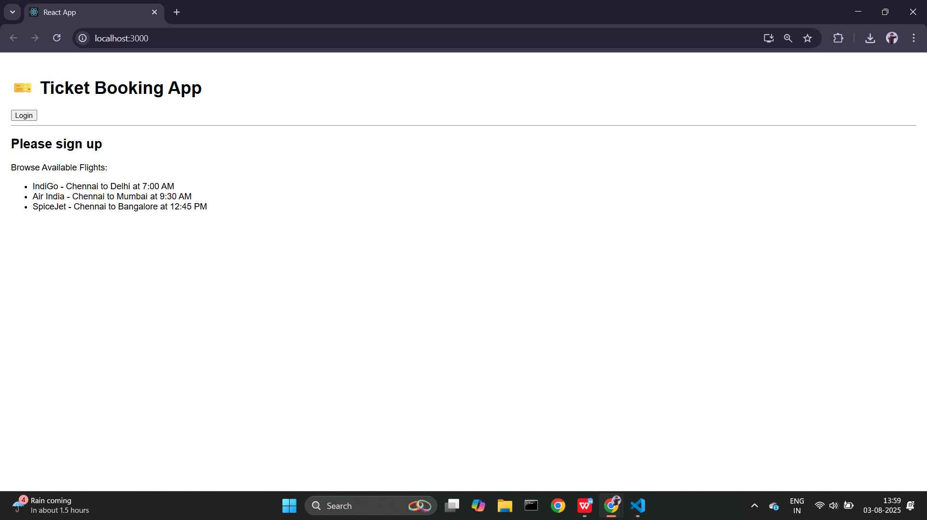

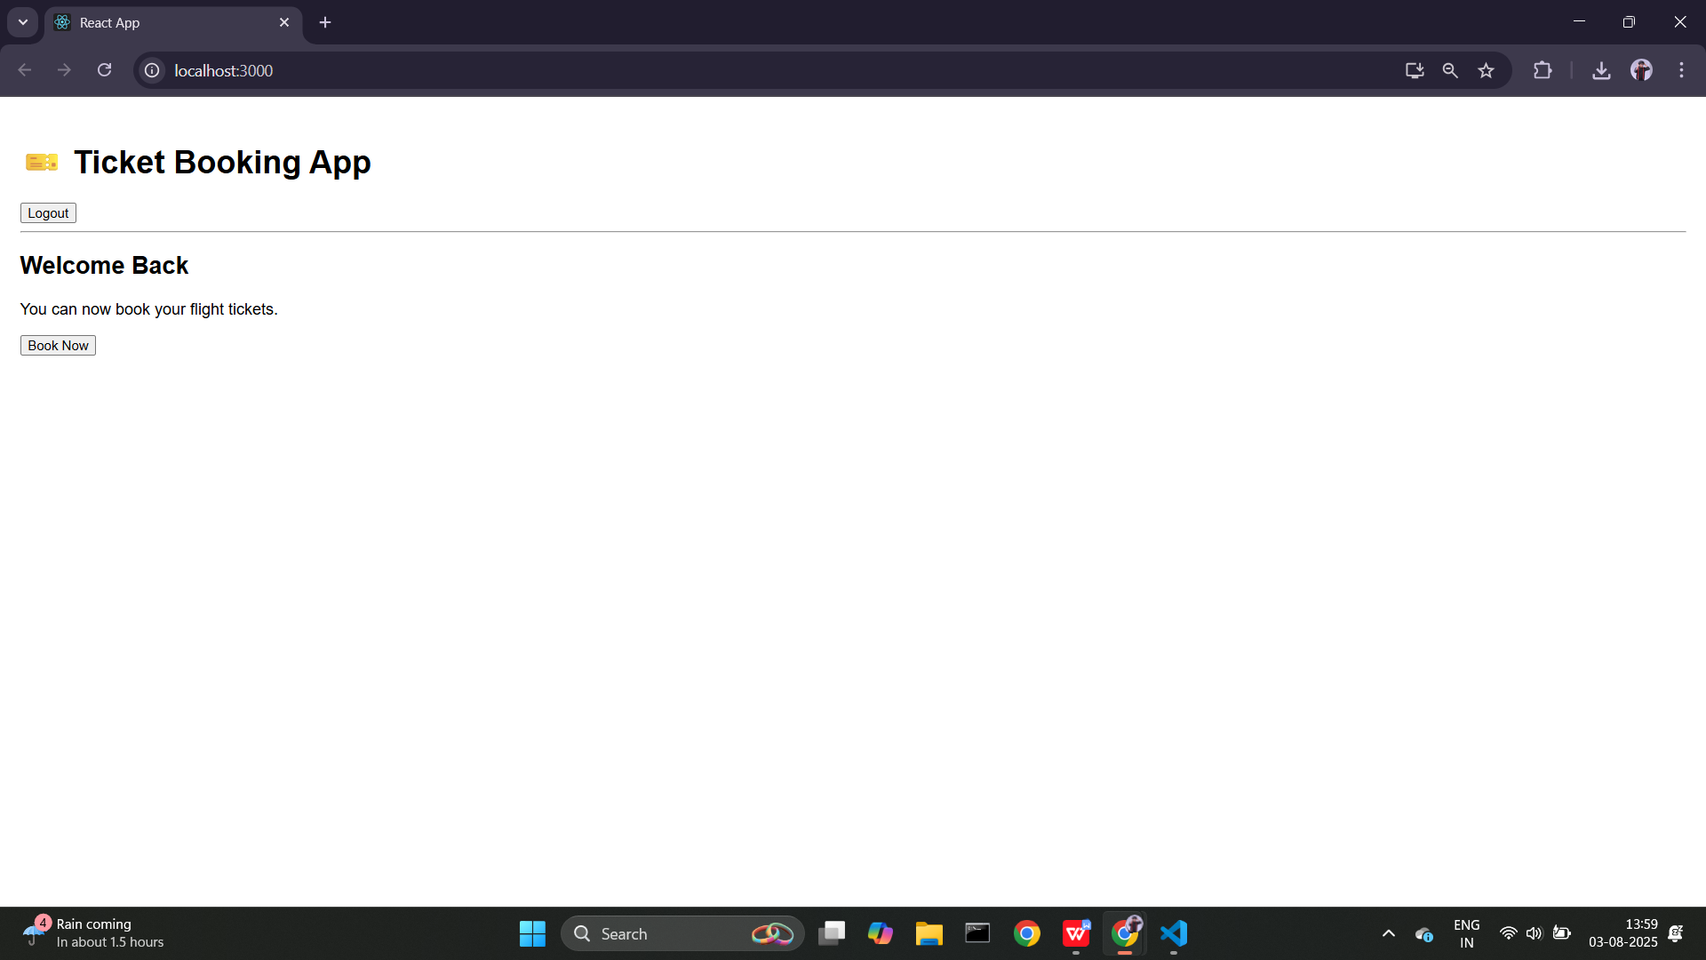

# Conclusion

This hands-on helped me practice conditional rendering and component separation based on app state.